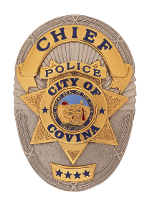

**COVINA POLICE**

**DEPARTMENT**

**STAY UP TO DATE WITH US:**

**@COVINAPD**



**@COVINAPD**





**CHIEF RIC WALCZAK**

**/COVINAPOLICE**

PRESS RELEASE

ASSAULT WITH DEADLY WEAPON

2/13/2025

Inc# 25-2621

On Thursday February 13, 2025 at approximately 3:40 AM, personnel from the Covina Police Department served a search warrant at a residence located at 757 S. Rancho Sinaloa Covina. The search warrant service was linked to an Assault with a Deadly Weapon investigation being conducted by the Covina Police Department.

Initially, nine people were detained at the location pending further investigation. This included a juvenile who was subsequently taken into protective custody by the Department of Children and Family Services. An adult at the location was transported to a local hospital after officers suspected the subject was suffering from a narcotics related complication.

While personnel were attempting to hail other occupants to exit the residence, including the primary suspect, a fire started within the residence. This fire prompted the primary suspect (Isha Stroschein/Age 39/Covina) to exit the residence with another adult. Stroschein and this adult were subsequently detained pending further investigation.

Los Angeles County Fire Department personnel extinguished the fire at the residence. A police officer was transported to a local hospital due to smoke inhalation. This officer was treated and subsequently released from the hospital. Los Angeles County Fire Department-Arson Unit responded to assist in this investigation.

Stroschein was arrested for 245 (A)(2) PC (Assault with a Deadly Weapon) and additionally charged with 30305 A1 PC (Possession of Ammunition by Prohibited Person). This case will be presented to the Los Angeles County District Attorneys Office for criminal filing purposes.

Case Agent: Detective O. Preciado (626) 384-5622

**FOR PUBLIC RELEASE**

**Covina Police Department**

**444 N. Citrus Avenue**

**Covina, CA**

**Non-Emergency: 626.331.3391**