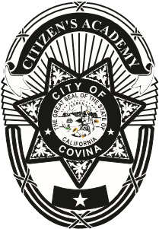
CITIZEN POLICE ACADEMY

- This is a free, 7 week program designed to provide residents and others, an overview of how the Police Department works and the services provided by the Covina Police Department.
- Attendance at each class is encouraged.
- Each week, students will learn about The Covina Police Department, meet the staff; have a better understanding of the tasks police officers face in their daily work. Students will learn about law enforcement’s role in the criminal justice system. Students can participate in a Building search, a Traffic Stop, and will “fire” in our range. They may also go on a ride along in a Patrol Car.
To apply for Covina Police Department Citizens Academy, complete the section below and mail to:
Covina Police Department,
Crime Prevention Unit
444 N. Citrus Ave., Covina, Ca 91723-2199

Or, Fax to 626-384-5629 or Email sveloz@covinaca.gov

Covina Police Departments Citizens Police Academy
Minimum age is 21 years old. No outstanding warrants, and / or no pending criminal cases. No felony convictions. Application will not be considered unless all requested information is provided. Please print or type.

Name:______________________________________________________ Date of birth:__/__/____
Home Address:__________________________________________ City:______________ Zip:__________
Mobile Telephone:_____________________ Email Address:_____________________________________
Occupation/School:________________________________________________________________________
Emergency contact:__________________________ Phone number:________________________________
Driver’s License Number:_____________________Exp:_________________Class:__________________
Have you ever been convicted of a crime?
Yes / No If “Yes” provide location and explanation ________________________________________________________________________________________Why do we need to know these things? Class participants will be visiting restricted areas covered under Homeland Security regulations.
By signing this application, I consent to a records check of my driving and criminal history. If accepted as a student, I agree to abide by all rules and regulations.

Signed:_________________________________________________________________Date:_____________

